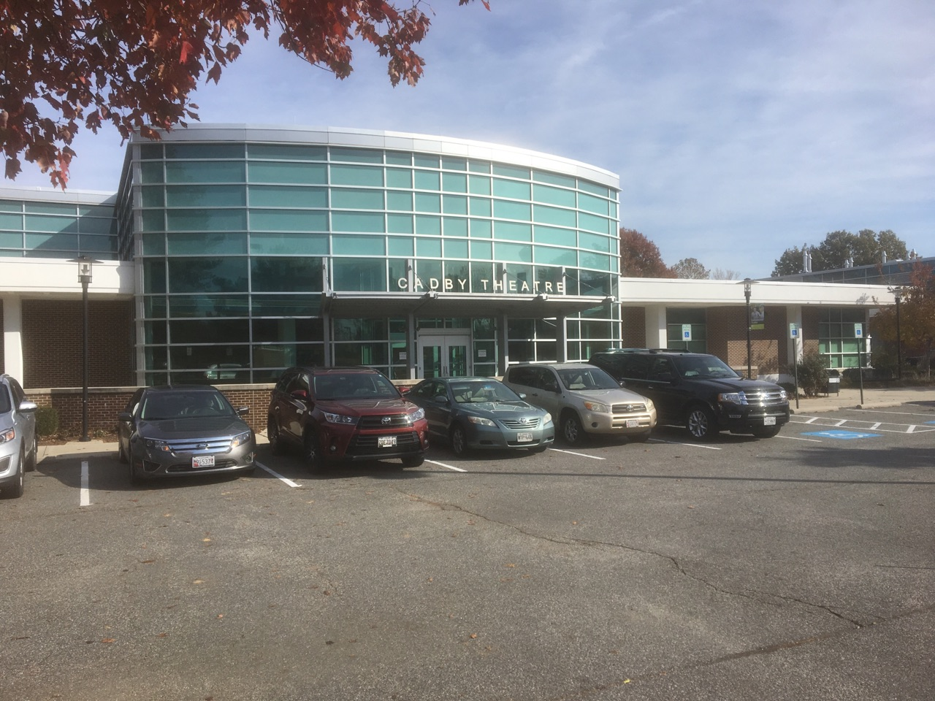

CADBY THEATRE
in
Humanities Building,
Chesapeake College
Wye Mills, MD 21679
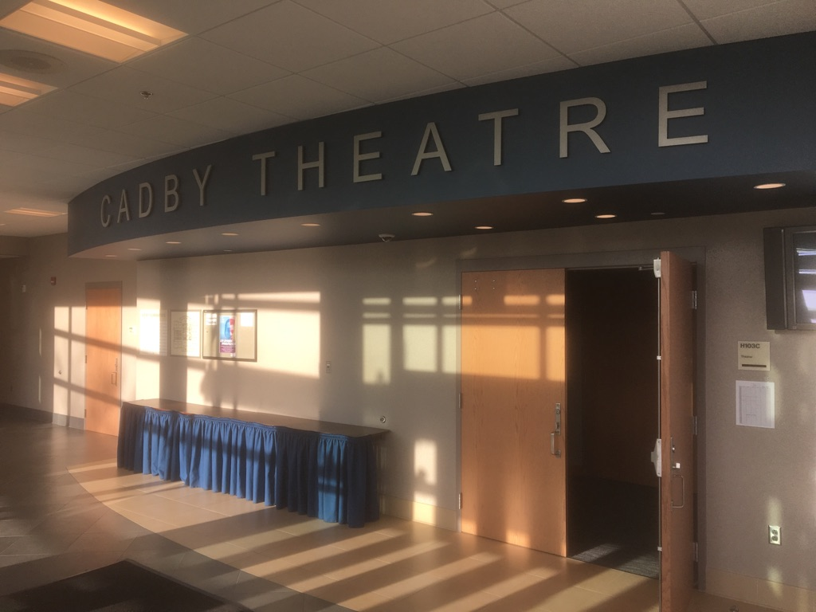
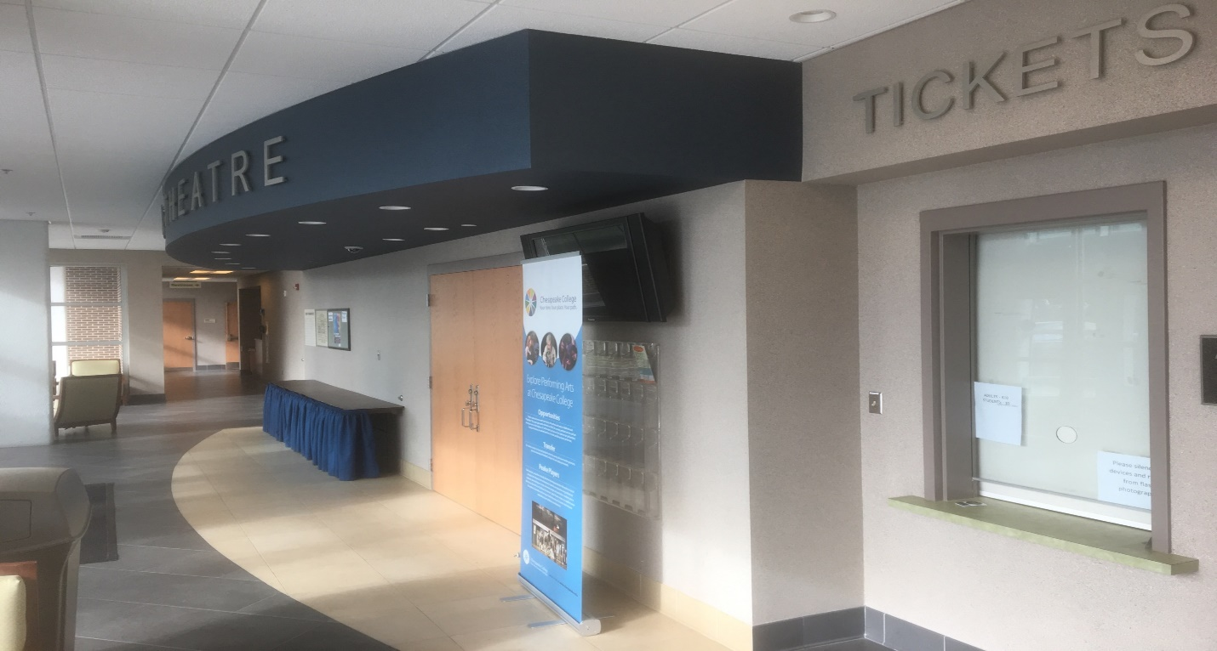

CADBY THEATRE Lobby in the HUMANITIES BUILDING

Cadby Theatre-Chesapeake College
Technical Information

Forward-
The Cadby Theatre is located in the Humanities Building on the campus of Chesapeake College, Wye Mills, MD. 21679. The front of the building and entrance to the theatre is best accessed from MD route 662 or enter the campus of Chesapeake College from MD route 50 and follow the circle drive around until you see the entrance. Cadby Theatre on the front of the building. There is a parking lot directly in front of the building
STAGE:
Stage grid is useable height of 8 feet from stage floor. Plan 7 feet for best clearances due to lighting instruments hanging positions
Proscenium arch is 26 feet wide
Stage Wall to wall is 52 feet wide
Stage is 15 feet deep at the Center Line
Stage is 2.5 feet above Room (Orchestra level) floor
Wing space approx. 13 feet - two black legs hang in wing space
Upstage curtain is Black on a walk-along track just in front of block wall which is Black Paint
There are step units SR and SL –three step units leading from audience to stage
Front of stage is arched (see photos for clarity)

ELECTRICS:
ETC Theatrical lighting system, -- ETC ION Control Board 96 dimmers including House Lights.
Most Instruments are ETC, some older Fresnel instruments and Par-Lite LEDS are included in the plot. Upstage strip lights are LED. Channels 101-107 run these on light board.
Hook up Sheet attached will show you Electric Locations and instrument types.
Most lighting instruments are not movable due to AV needs within the room and locations. Some specials will be available and focus will be from a ladder.
SOUND:
FOH position is in the control booth, Soundcraft board, a PC computer is patched into system for sound playback via thumb drive or off internet. Mini-plug input available for laptop or other device input into sound system. Microphone inputs are XLR various points around the theatre. Speakers are EV—SL and SR near proscenium for FOH speakers; multiple choices through the “mix” and “location “buttons on the Soundcraft board. Additional EV speakers available on side walls of theatre for effects if desired.
Headset system available (wired) from booth to backstage on SL
NOTE the theatre has Audio-visual capabilities too. Two AV screens are located on/over stage, one downstage, and one upstage. Yes sometimes they are in the way for theatrical productions!
BACKSTAGE:
Green room area behind stage containing two dressing rooms, there is one rest room-no showers.
Load in: through building hallway. Typically we load in from parking lot in front of building.
There is a Box Office to the right of main entrance doors into theatre.

For more information contact
Richard S. Peterson CVE, Executive Director
Todd Performing Arts Center
Chesapeake College
1000 circle Drive
Wye Mills, MD 21679
TEL: 410-827-5868

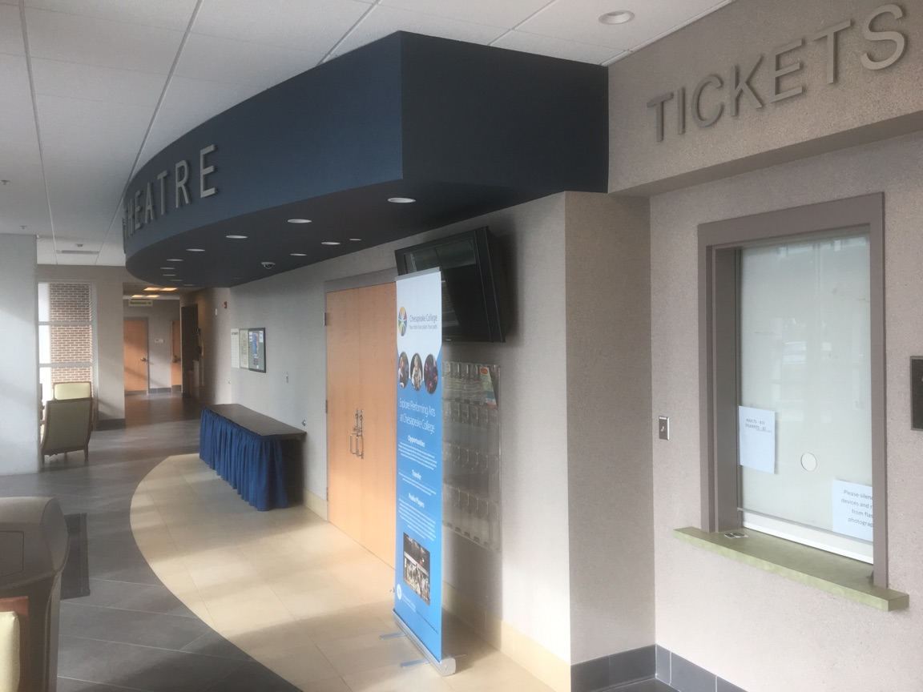
Cadby Theatre entrance in Humanities Building and Box Office

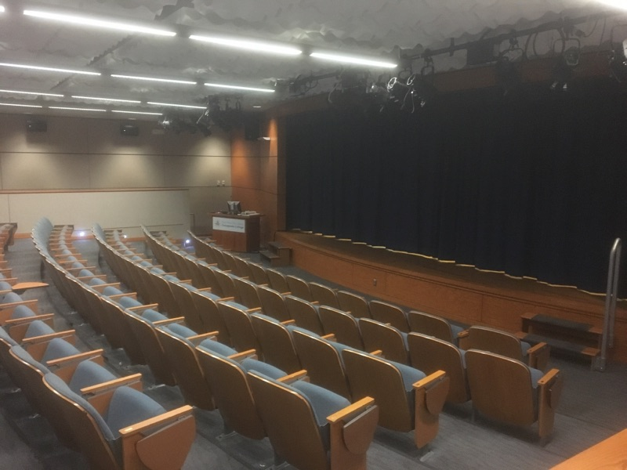
Audience shot from HR main curtain closed
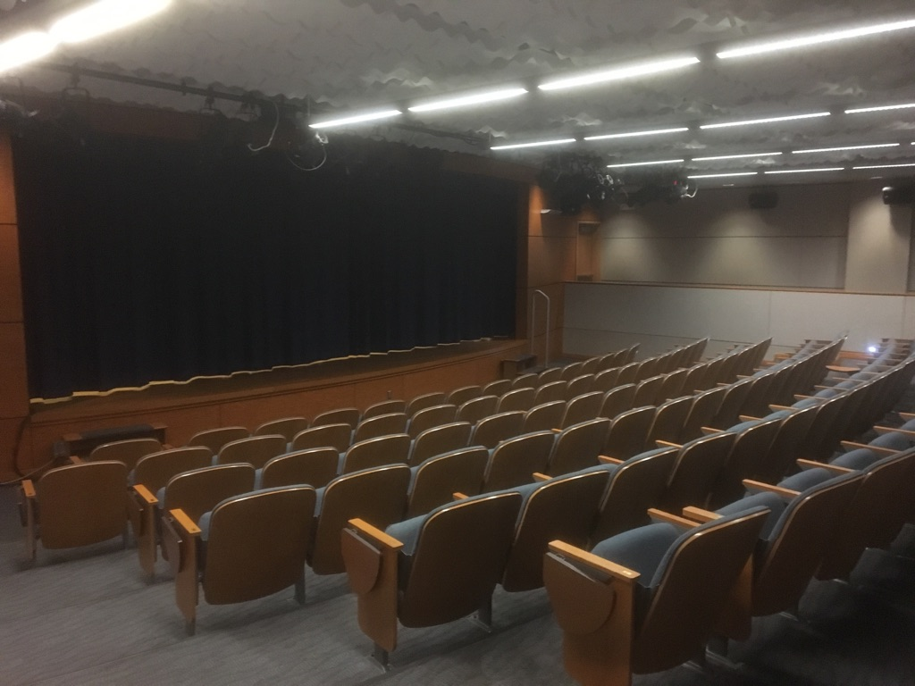
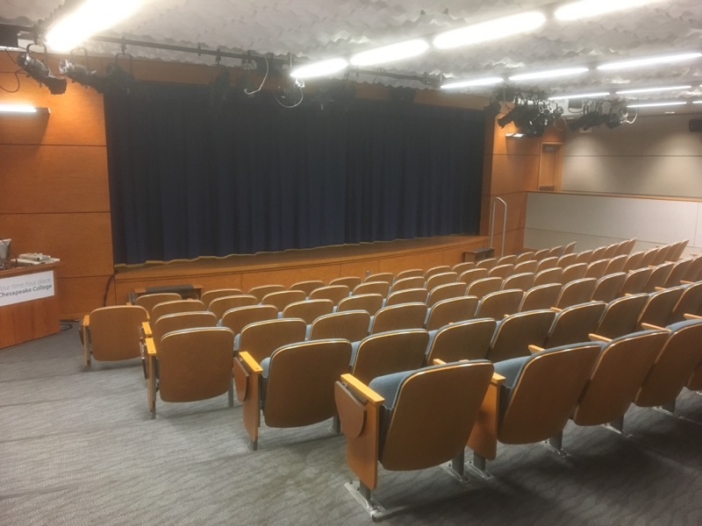
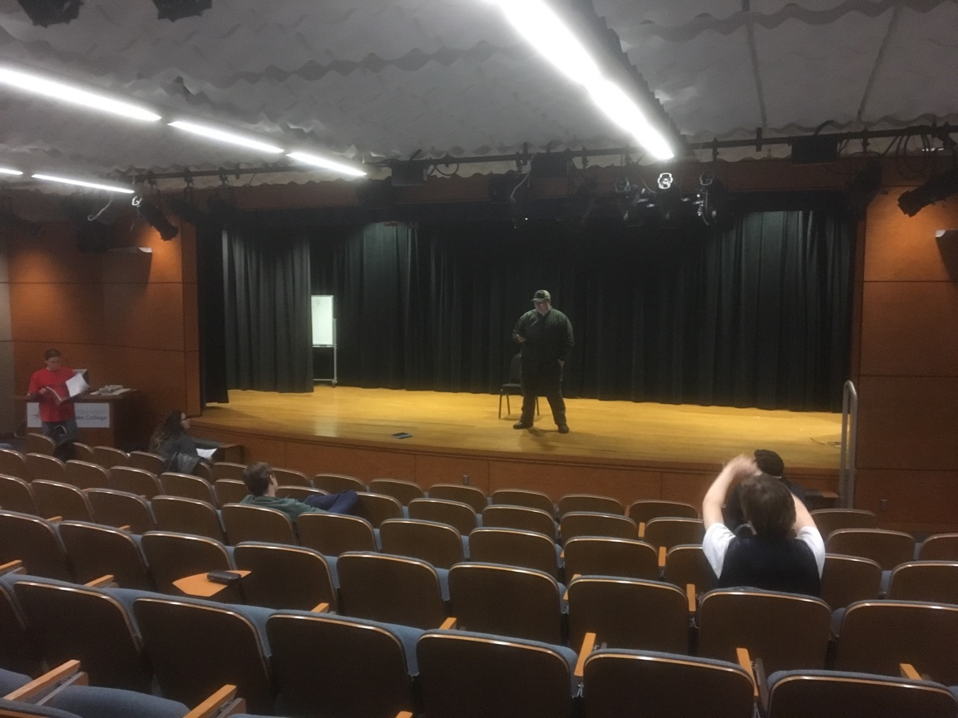
2 views of audience seating 100 seats showing FOH2 stage electric
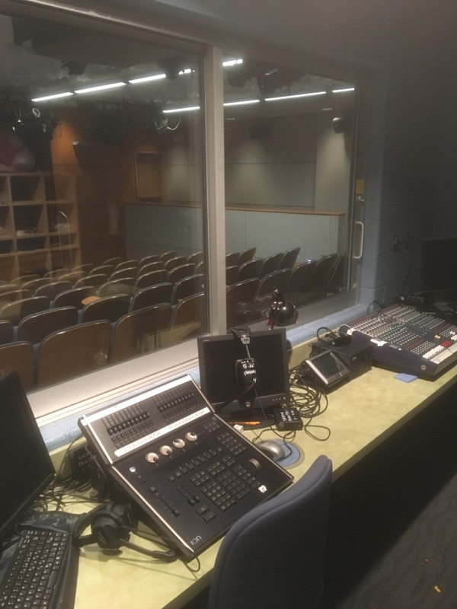
Control Room- ETC Light Board foreground, Soundcraft Audio in back
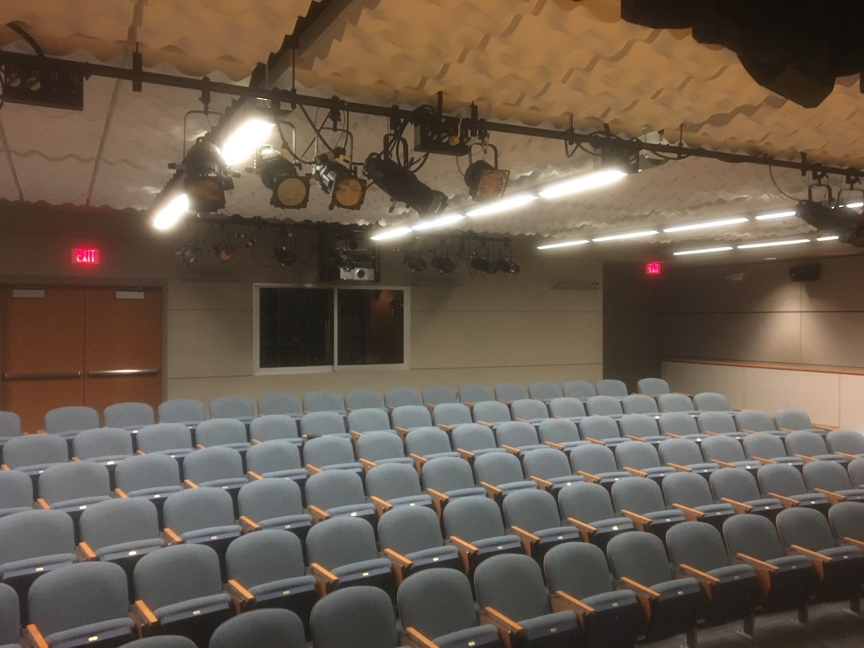
Control Room at rear of seating
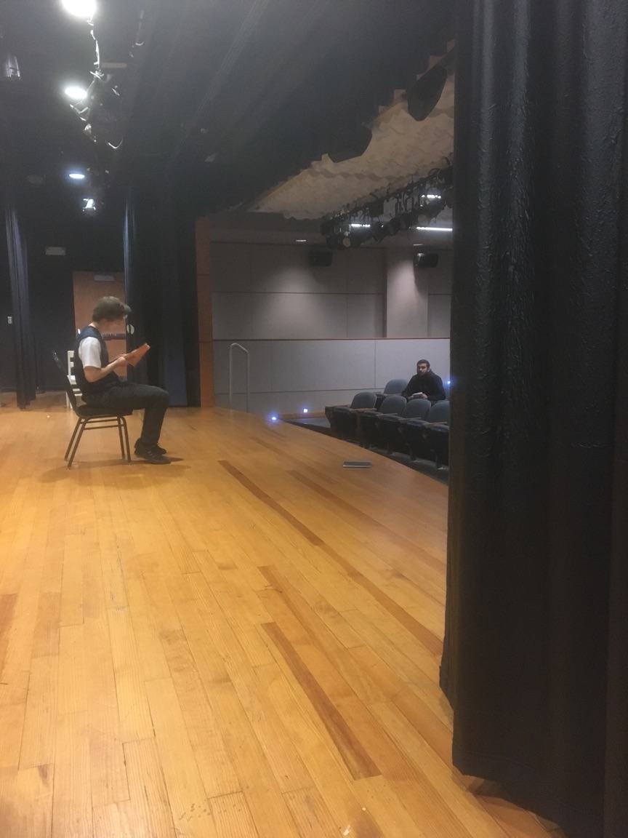
SR looking on stage-

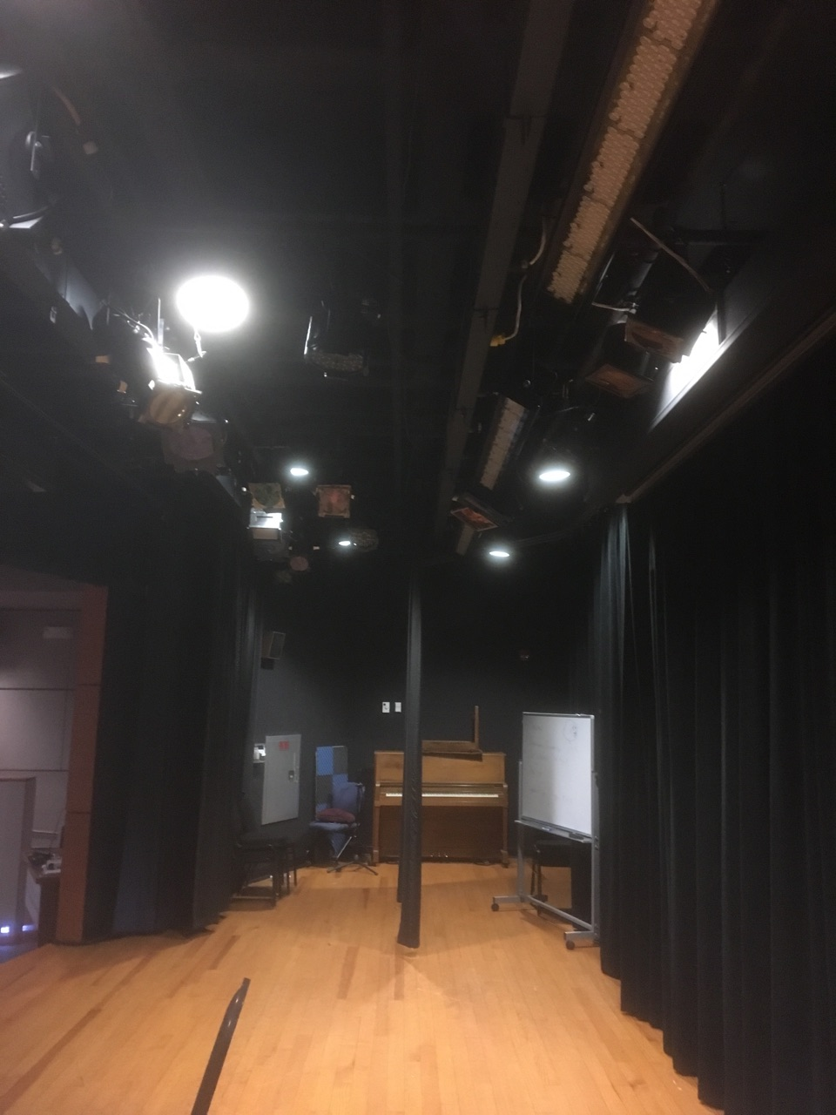
SL looking onstage-note grid and electrics Black curtain is Back Wall

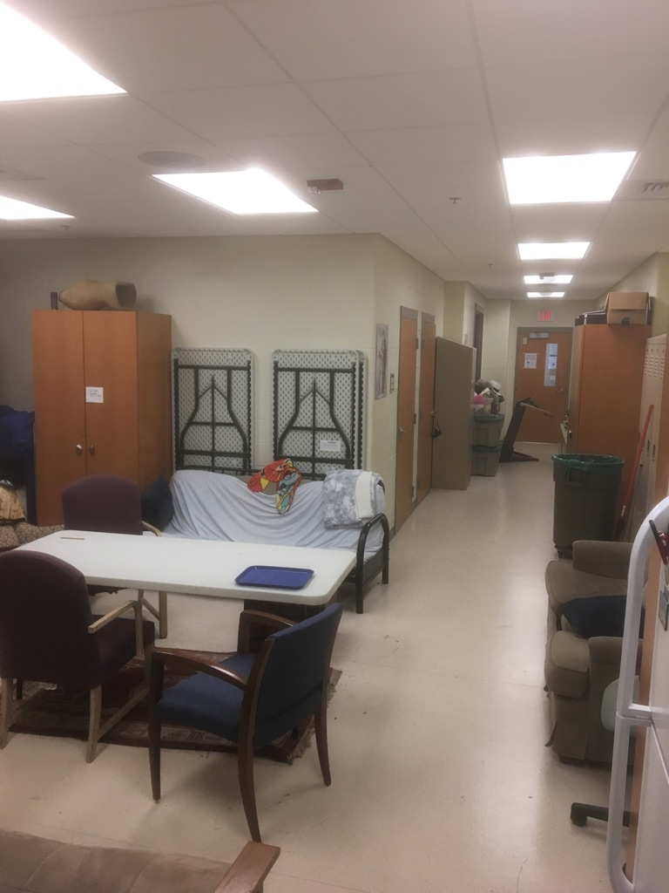
Backstage/Green room-dressing rooms at the left behind table stack
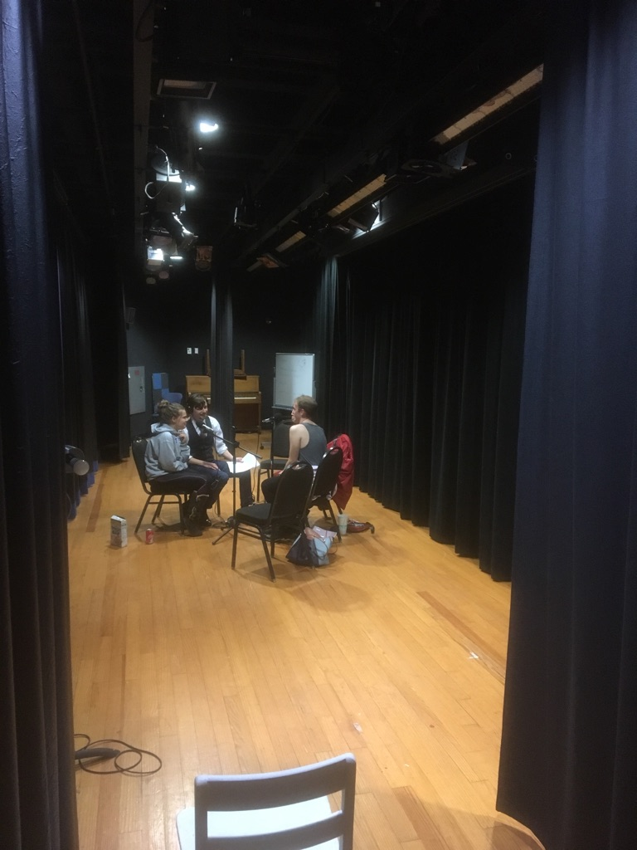
Stage from SL with Main Curtain closed upstage Black closed

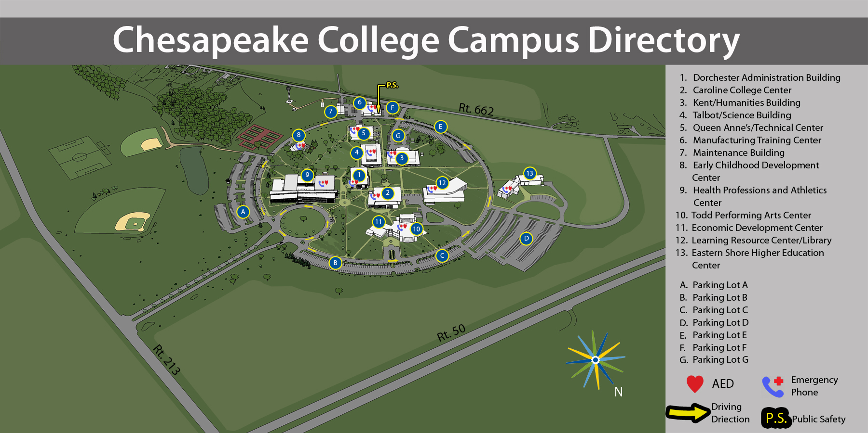
Cadby Theatre located in Building 3 Kent/ Humanities Building

Document Produced- November 14, 2019

